Workshop Model Planning Guide Date:

 | Monday | Tuesday | Wednesday | Thursday | Friday
Mini-Lesson
Independent Work
Group Work
Sharing

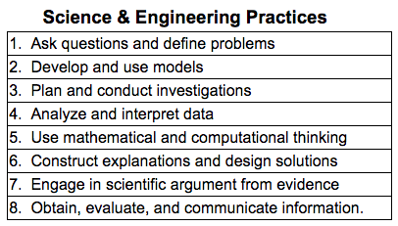
Workshop Model for Secondary Science
10-20 min: Mini Lesson
Opening discussion about something relevant to the topic of study.

20-30min: Independent Work
Students work on something alone.

20-30min: Group Work
Students work to complete a task as a small group

5-10min: Sharing
Teacher leads students to share what they learned in class today.

Group time and Independent time may be interchanged. Incorporate the SEPs daily.

